Model Development Phase Template

|  |  |
| --- | --- |
| Date | 20-06-2025 |
| Team ID | SWDTID1749906902 |
| Project Title | Early Stage Disease Diagnosis System Using Human Nail Image Processing |
| Maximum Marks | 4 Marks |

**Initial Model Training Code, Model Validation and Evaluation Report**

The initial model training code will be showcased in the future through a screenshot. The model validation and evaluation report will include classification reports, accuracy, and confusion

matrices for multiple models, presented through respective screenshots.

**Initial Model Training Code:**

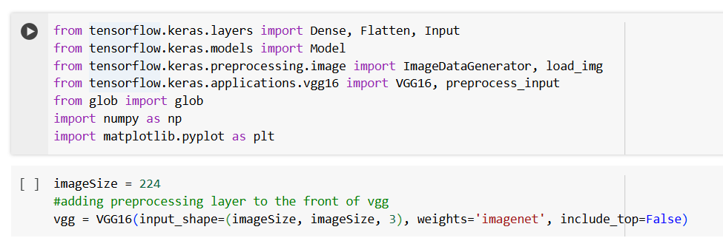

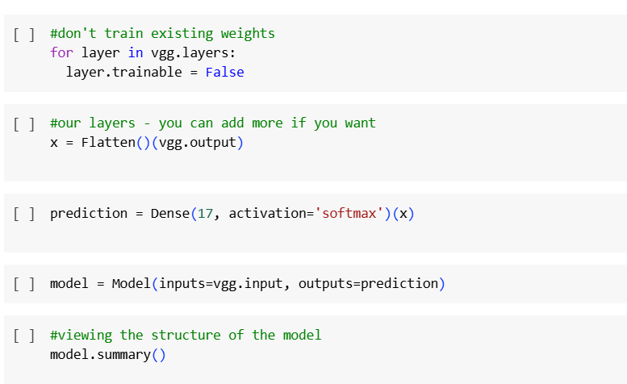

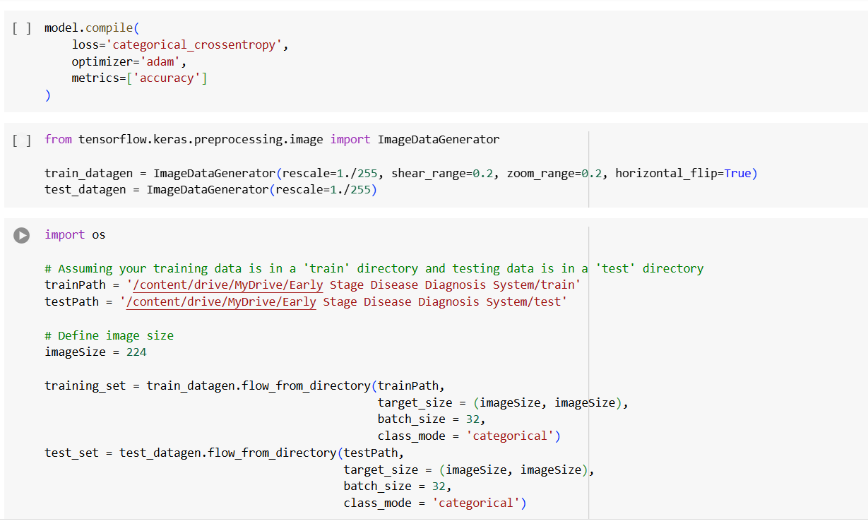



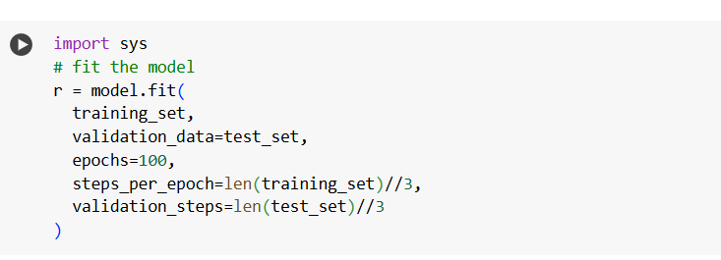

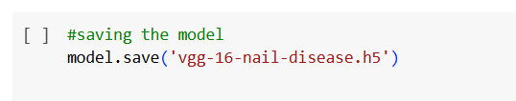

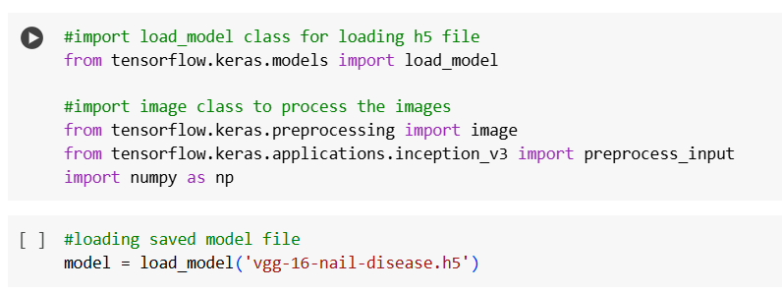

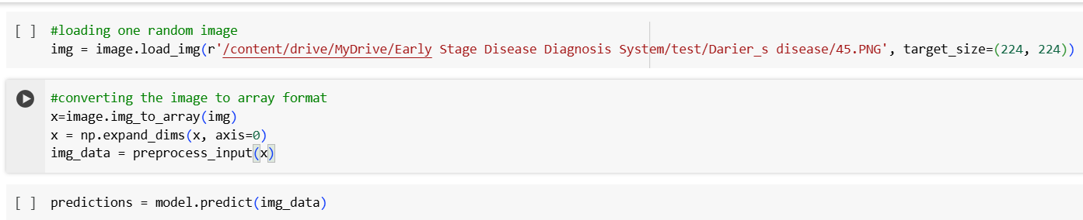

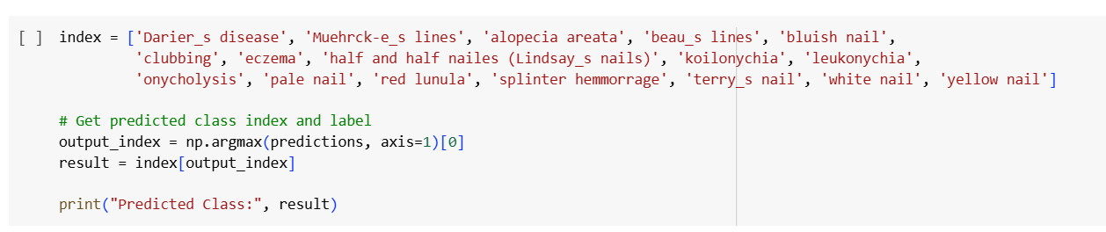

**Model Validation and Evaluation Report:**

|  |  |  |  |
| --- | --- | --- | --- |
| **Model** | **Classification Report** | **F1**  **Scor e** | **Confusion Matrix** |
| TensorFlow / Keras | - | 81% | - |

|  |  |  |  |
| --- | --- | --- | --- |
| VGG16 Model | **-** | 79% | **-** |
| |  | | --- | | Flask |  |  | | --- | |  | | **-** | 64% | **-** |
| |  | | --- | |  |   flask_cors.CORS | - | 78% | **-** |